ip : internet protocol
it controls routing of information to different computers, different devices,different servers on the network
public ip range

class A 0-127
class B 128-191
class c 192-223
class D 224

Pvt ip range

class A 10.0.0.0
class B 172.16.0.0
class C 192.168.0.0

Subnet mask
it is a way to segment a network logically so that different computer in different devices cannot nessasery talk to other computer and devices on the same physical network
Default gate way
its the router for the sub network that ur on
DHCP
every device on an network need an ip adress without ip device cannot communicate
u can give static or dynamic ip to a device
NAT(Network adress translation)

Subnetting
number of ip in subnet is 2^n -2 (1 network id and 2 is brodcast id)
number of subnet is 2^n

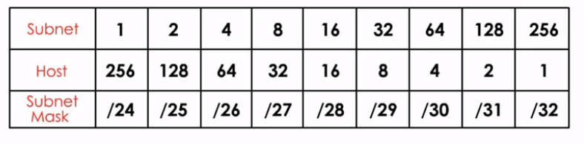

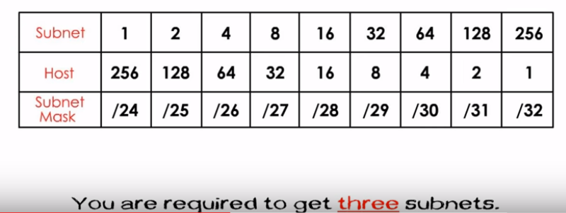

u can have 3 subnets so u have to take 4 subnets

